**About Us:**

HELP Educational Society, sprang up in 2001in the city of Bathinda, Punjab with a sole aim to provide the state with SKILLED workforce by transformation of unskilled workforce. The idea came to the mind of Mr. R.T Goyal, the chief originator of this NGO, when he found that with the existing infrastructure of his educational institution (BIMT), he can help the young generation by imparting much needed Vocational training and subsequently arranging for their placements.

The trainings provided are free of cost and for helping the real needy, who due to illiteracy or family constraints were unable to complete or left their studies and had to work as Un-skilled workers.

This NGO also invites students from Domestic & International Colleges for completing their Field Trainings in the form of teaching the students in specific fields; working in nearby village schools by educating them in different subjects; manually working for development of school’s infrastructure.

The NGO runs from the same office with **BIMT**, which has been imparting education in Information Technology and is affiliated to **Punjab Technical University, Jalandhar**. The NGO possesses desirous facilities like Computer Labs, Projectors, well equipped library, High speed Internet connection to help needy students with the best possible manner.

This society is **Non–Political, Non-Commercial** and **Non-Profitable**.

**Activities:**

1. Society shall impart value based schooling education by opening schools in rural, semi-rural and Urban areas; therefore improve the educational/learning scenario in Punjab and uplift the youth without any distinction on the basis of caste, creed or religion, in the interest of mankind in general.
2. Society shall provide concessional/free education to downtrodden, handicap, and needy students on case basis.
3. Society shall also impart vocational education/training to help students become self-dependent by opening Vocational training centres & hence eradicating unemployment
4. To propagate & adopt audio/visual methods of imparting education to handicap students.
5. Society shall work for National development by improving education system, aiding/establishing institutions, and adopting means for promotion of Art, Science or any other field of education.
6. To open Libraries & Reading rooms; to aid/establish & takeover/collaborate with any institution/school/ association for physical, mental, spiritual, educational development, & upliftment of society.
7. To arrange or provide first aid such as medical aid and such other assistance necessary for living to the needy persons who are otherwise incapable, handicapped, mentally or physically retarded.
8. To arrange or provide timely help or aid to the families of the workers of the society.
9. To control pollution and to make the aware of the methods and devices to control pollution.
10. To control population of the country by spreading awareness among people about various family planning measures.

**Field Trainings/Internships:**

**Field Trainings/Internships of Graduating students of Educational Institutions:** Besides the above mentioned activities NGO actively further arranges **Field Trainings for students/volunteers from Foreign Nations.**

***Internship Overview Location***: India (Northwest region)

***Language of Instruction***: English

***Duration***: 2 to 12 months

***Career/Psychological Benefits include***:

* Life time Personal / Learning / Professional experience
* Academic / Course credit (when available)
* Exposure to Indian culture and market

***Nature of Work*:** The students who are undergoing the **Humanities/Social Sciences/Human Development** or any course pertaining to Society Development are invited in our NGO to spend their Training semester or free time for getting an exposure of actual Site volunteering- in the village schools, blind schools, villages- helping societies or underdeveloped areas of cities. They can contribute by actually teaching the children at local schools, giving vocational trainings, educating them about various aspects of life, developing infrastructure at schools/villages/local development centres by volunteering and spending time with the downtrodden.

The exact nature of the work which the intern will do depends on following factors:

1. The intern and her/his qualifications and interests;
2. The projects and the programmes which Help-EDU, is engaged at the time he/she is with us.

It is important to us that an internship with Help-EDU is a valuable experience. This means that our goals and aims should be furthered through the work the intern does while he/she is able to grow personally, maximising the benefit gained from being with us. For this reason, we start off by developing a work-programme, to give clear structure to interns' time with us (although naturally it remains flexible). We would appreciate people that take the effort to learn about us and how they can become part of our team and help us in developing the society. Keep in mind that we are looking for people that will be passionate about the Societal Development are motivated to make things happen.

***Project Locations & Accomodations***: Northwest India (Villages & towns). The stay arrangements, Inviting letters and other formalities will be taken care of by the NGO as per the requirement.

***Areas of Work***: Education, Vocational training, Girls' & Women empowerment, Children and Youth development, Healthcare awareness, Environment Conservation, Micro-finance, E-administration, Sustainable rural development, Organic Farming.

***Working Hours***: Full-time (Mon-Fri)

***To Apply:*** Send your CV and motivation letter to [rtgoyal@gmail.com](mailto:rtgoyal@gmail.com) and [ravneet.bhalla2002@gmail.com](mailto:ravneet.bhalla2002@gmail.com)

***Types of Internship available***: An intern's area of work will depend on their experience, knowledge, motivation and duration of stay. We coordinate interns to projects in which they have more knowledge or experience, and that they are most motivated towards developing. Their role will depend on the length of the internship and the intern's preference. Interns staying for longer have more scope to take on higher level positions within the NGO; although they are not obliged to.

Before applying for a Field Training/Internship, you should think about the areas which your character traits are suited for, based on:

* Your knowledge
* Your experience
* Your motivation/interest
* Your skills
* Your personality
* Your duration of stay

As mentioned, internship positions can be Project based (focusing on a specific project) or Activity based (working across all projects).

**WE JUST NEED YOUR WILL AND DESIRE TO CONTRIBUTE FOR THE BETTERMENT OF THE SOCIETY AND MANKIND AT LARGE; IN RETURN WE CAN ASSURE YOU THE SATISFACTION, SENSE OF RELIEF AND PURPOSE OF YOUR LIFE.**

**Team:**

**Governing Body:**

1. President:- **Mr. R. T Goyal**

Mr. Goyal, a dynamic and young personality among the new breed of enterprising young people in today’s world is a B.Tech. in Aeronautical Engineering from Indian Institute of Aeronautical Engineering, Dehradun and has undergone trainings in Simulation & Training from the Canadian Aeronautics & Space Institute, Ontario and The American Institute of Aeronautics & Astronautics, Washington.

During the course of his achievements, he has been a member of the **Red Cross Society** of India & has also been accredited for his excellence in overall academic and professional performance **by Marlborough University, Honolulu, State of Hawaii, USA** and as such been confirmed as a **honorary member for life of their Alumni Association**. Mr. Goyal has contributed a number of articles on aeronautics to a various publications in N. Bombay. He has been a counsellor and instructor at the Indian Institute of Aeronautical Engineering.

He possess a heart of philanthropist, and have an urge for the betterment of the neglected and down-trodden section of the society; for realizing these dreams into reality, he has helped a lot by donating to the desired ones and joined as a General Secretary of “All India Crime Prevention Society” Chandigarh, and for his untiring work and commitment to provide the justice to the needy section of the society he has been Honoured may times.

In year 2001 Mr. Goyal materialized his vision of starting an Institute: **Bathinda Institute of Management & Technology (BIMT)** & in year 2003: **HELP-EDUCATIONAL SOCIETY (REGD) NGO** was established to impart technical & vocational education to the youngsters of Punjab. While undertaking this task successfully, he felt a strong need for eloquent communication skills among his students, for which he has joined hands with AIAA (USA), became its Educator Associate and started CELL-INDIA (Centre for English Language Learning). With the advent of CELL-INDIA in BIMT, Mr. Goyal’s long cherished dream of imparting education through play way method was finally accomplished.

b) Vice President

c) General Secretary

d) Secretary (Admn)

e) Secretary (Finance)

f) Secretary (Academics)

g) Executive Member

h) Members

**Overall Coordinator:** Mr. Ravneet Singh Bhalla

An active associate of the NGO, he is currently working as Assistant Manager in HPCL-Mittal Energy Ltd. and did his Mechanical Engineering from Thapar University, Patiala.

He handles coordination with other volunteers of the NGO and identifies the Needy students, formalize their course/training start in the NGO and bridge the gaps wherever needed.

**Volunteers:**

1. Mr. Utkarsh Jain:-

An idea generator of the NGO, he is working as an Engineer in HPCL-Mittal Energy Ltd. He has completed Chemical Engineering from prestigious engineering Institute: IIT-Delhi. He has been very active in various research works & implementing development ideas in college.

1. Mr. Manav Manocha:-

A Software developer by profession, Mr. Manav he has completed his Electronics Engineering from NIT-Jalandhar and handles the communication and Website developing for NGO. He is working as Developer in Compro Technologies.

**Gallery:**

1. Certificate of Registration: 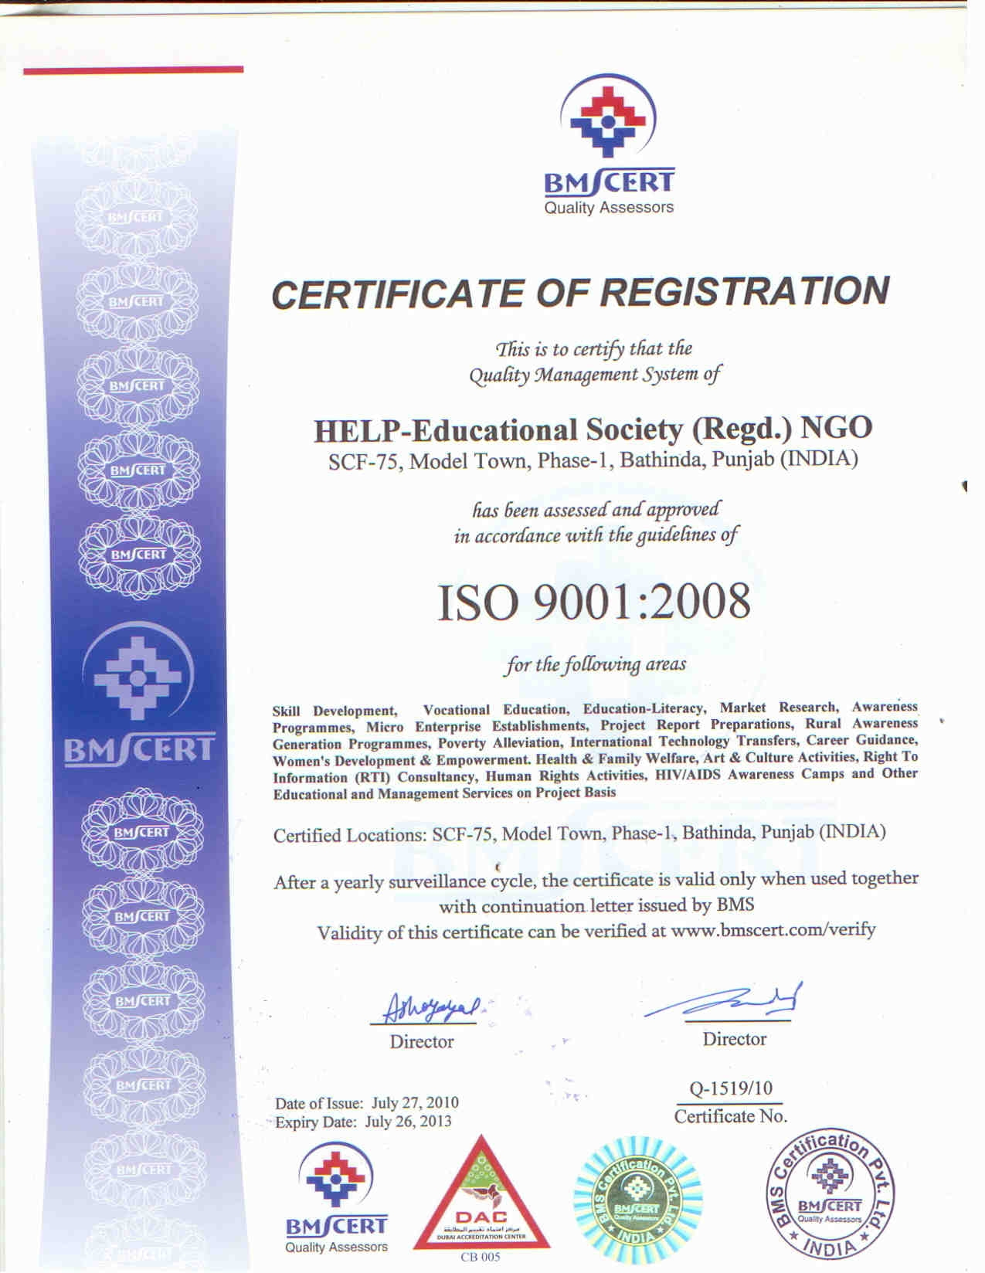
2. Certification of Registration of Societies:

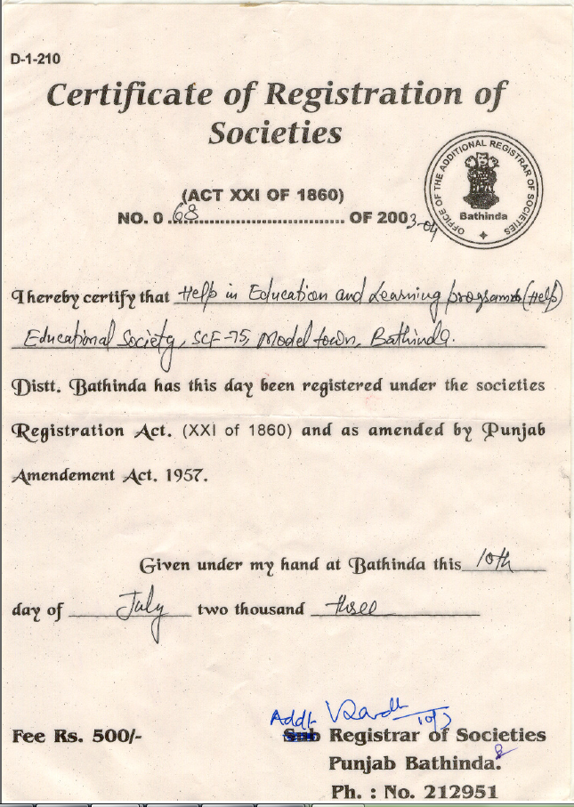

**Become a Volunteer:** Will be coming soon……….

**Contact us:** Will be coming soon……………

**Links:** Will be coming soon………….